**Year 12 Examination, 2018**

**Question/Answer Booklet**

**MATHEMATICS SPECIALIST**

**Section One: Calculator-free**

Student Name/Number: ______________________________________________

Teacher Name: ______________________________________________

**Time allowed for this section**

Reading time before commencing work: five minutes

Working time for this section: fifty minutes

**Materials required/recommended for this section**

**To be provided by the supervisor:** This Question/Answer Booklet

Formula Sheet

**To be provided by the candidate:**

Standard items: pens (blue/black preferred), pencils (including coloured), sharpener,

correction fluid/tape, eraser, ruler, highlighters

Special items: nil

**Important note to candidates**

No other items may be taken into the examination room. It is **your** responsibility to ensure that you do not have any unauthorised notes or other items of a non-personal nature in the examination room. If you have any unauthorised material with you, hand it to the supervisor **before** reading any further.

**Structure of this paper**

|  |  |  |  |  |  |
| --- | --- | --- | --- | --- | --- |
| Section | Number of questions available | Number of questions to be answered | Working time (minutes) | Marks available | Percentage of exam |
| Section One: Calculator-free | 7 | 7 | 50 | 54 | 35 |
| Section Two: Calculator-assumed | 13 | 13 | 100 | 100 | 65 |
|  | | | | | 100 |

**Instructions to candidates**

1. The rules for the conduct of School exams are detailed in the *_______________________________________School/College assessment policy*. Sitting this examination implies that you agree to abide by these rules.
2. Write your answers in this Question/Answer Booklet.

3. You must be careful to confine your responses to the specific questions asked and to follow any instructions that are specific to a particular question.

1. Spare pages are included at the end of this booklet. They can be used for planning your responses and/or as additional space if required to continue an answer.
   * Planning: If you use the spare pages for planning, indicate this clearly at the top of the page.
   * Continuing an answer: If you need to use the space to continue an answer, indicate in the original answer space where the answer is continued, i.e. give the page number. Fill in the number of the question that you are continuing to answer at the top of the page.
2. **Show all working clearly.** Your working should be in sufficient detail to allow your answers to be checked readily and for marks to be awarded for reasoning. Incorrect answers given without supporting reasoning cannot be allocated any marks. For any question or part question worth more than two marks, valid working or justification is required to receive full marks. If you repeat any question, ensure that you cancel the answer you do not wish to have marked.
3. It is recommended that you **do not use pencil**, except in diagrams.
4. The Formula Sheet is **not** to be handed in with your Question/Answer Booklet.

**Section One: Calculator-free 35% (54 Marks)**

This section has **seven (7)** questions. Answer **all** questions. Write your answers in the spaces provided.

Spare pages are included at the end of this booklet. They can be used for planning your responses and/or as additional space if required to continue an answer.

* Planning: If you use the spare pages for planning, indicate this clearly at the top of the page.
* Continuing an answer: If you need to use the space to continue an answer, indicate in the original answer space where the answer is continued, i.e. give the page number. Fill in the number of the question that you are continuing to answer at the top of the page.

Suggested working time: 50 minutes.

**Question 1 (5 marks)**

Calculate all four solutions of the equation

 

leaving your answers expressed in polar form with arguments in the range .

**Question 2 (12 marks)**

1. Use double-angle formulae to evaluate

 . (4 marks)

1. Use the substitution  to determine  . (4 marks)

1. Determine the value of the integer  if

 . (4 marks)

**Question 3 (9 marks)**

(a) Match the following three slope fields with their differential equations. (2 marks)

(A) (B) (C)

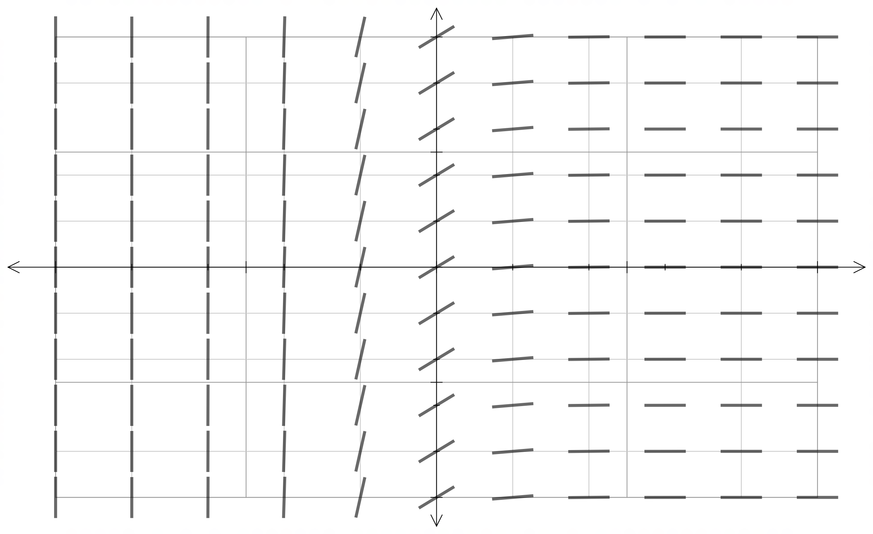 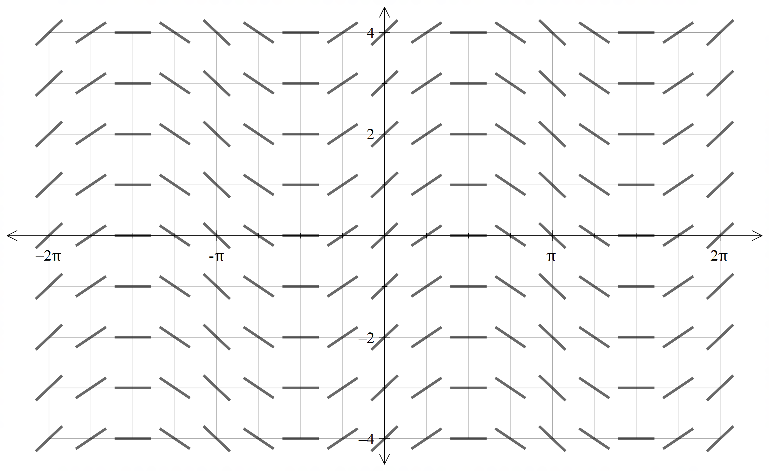 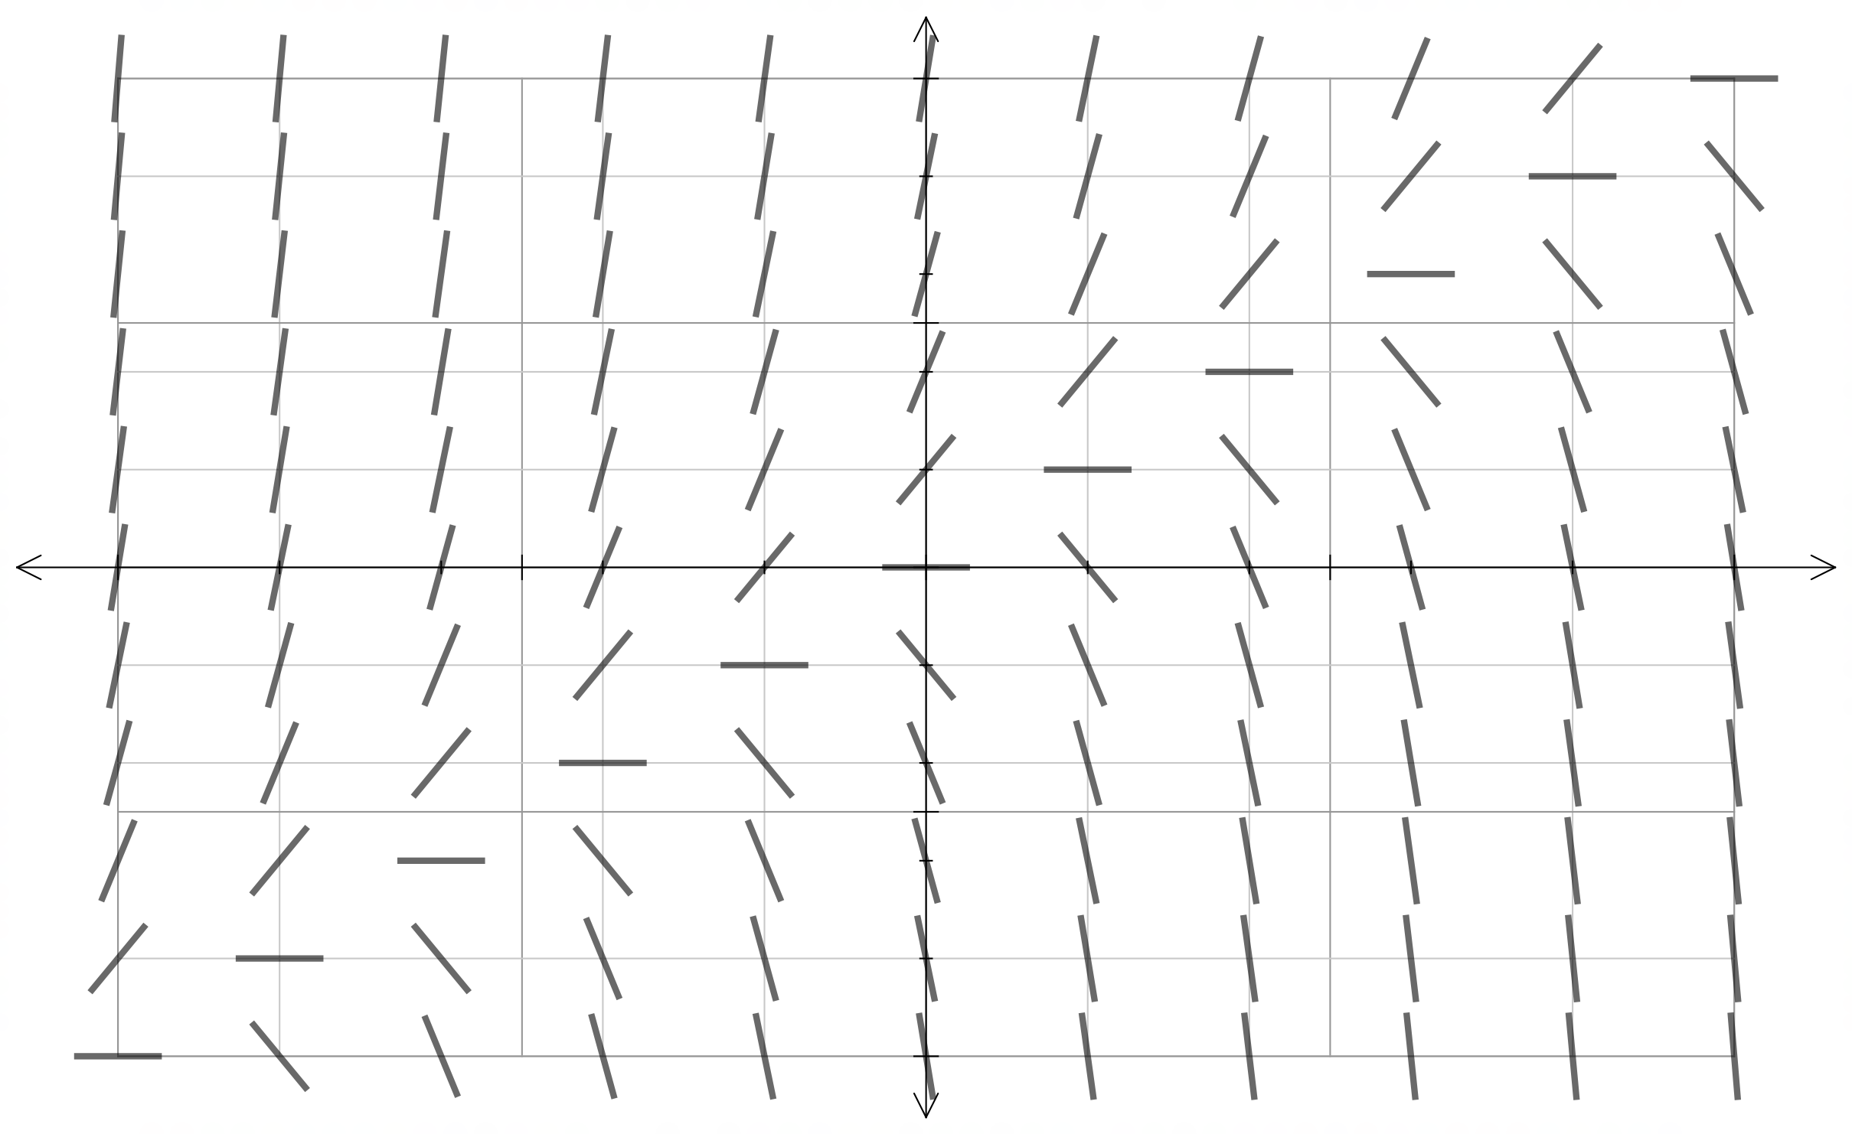



Slope field A corresponds to differential equation ………

Slope field B corresponds to differential equation ………

Slope field C corresponds to differential equation ………

(b) Consider the differential equation .

1. Let  be the particular solution of this differential equation with the initial condition .

Does  have a relative maximum, a relative minimum, or neither at ? Justify your answer. (3 marks)

1. Determine the particular solution to the given differential equation with the initial condition . (4 marks)

**Question 4 (6 marks)**

The graph of  is shown below.

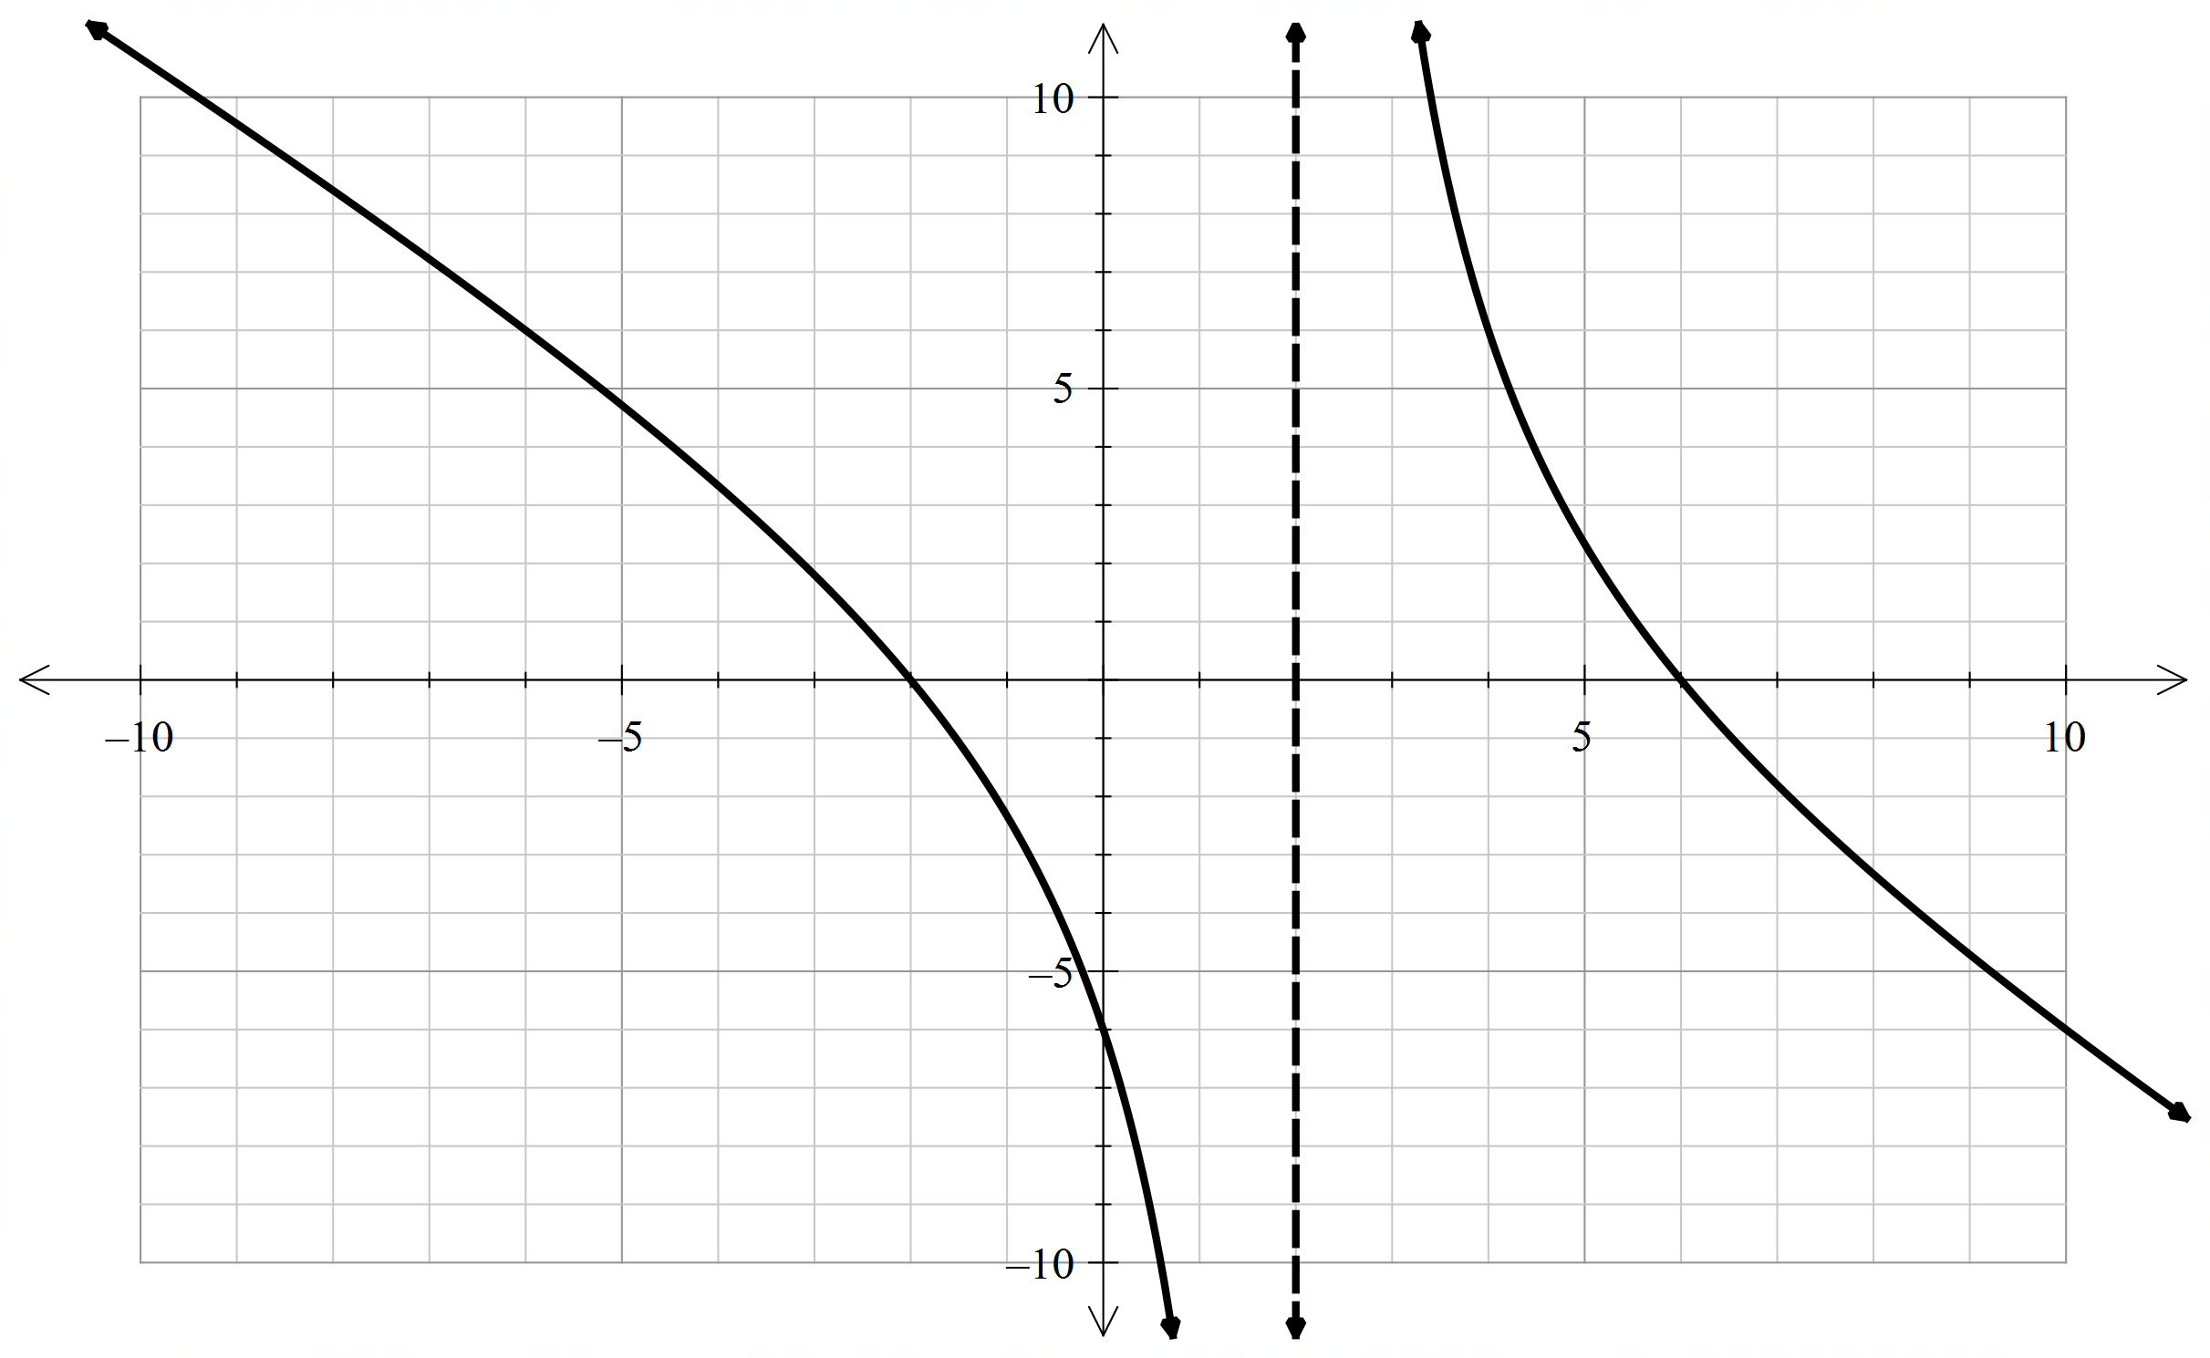

(a) Sketch the graph of . (3 marks)

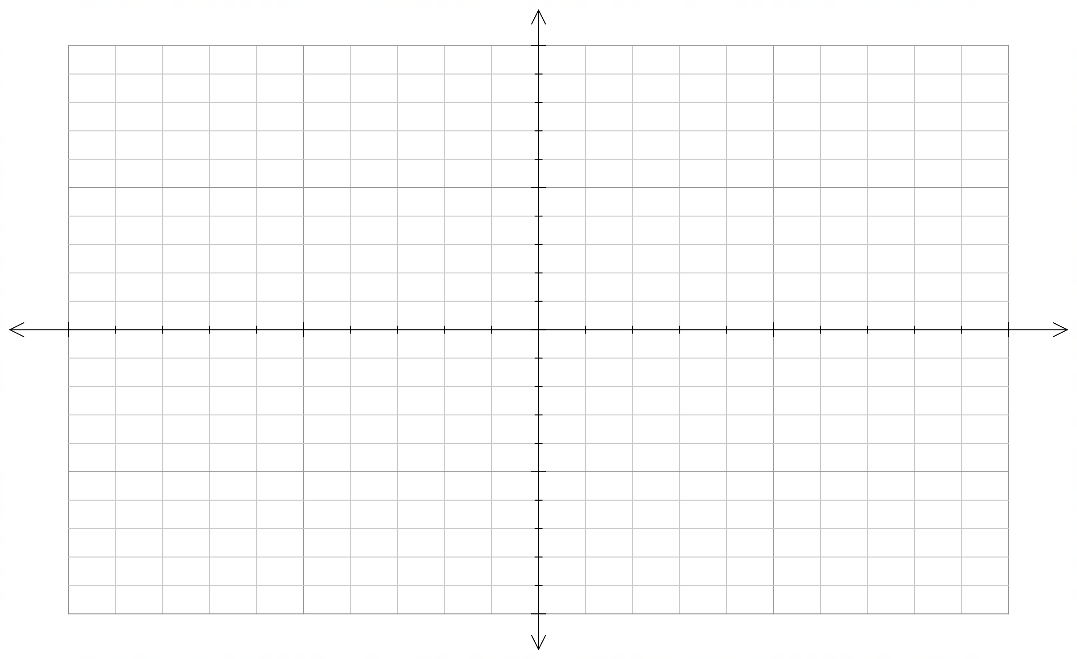

(b) Sketch the graph of . (3 marks)



**Question 5 (8 marks)**

The Cartesian equation of a sphere S is

.

1. Determine the radius of S and the co-ordinates of its centre. (2 marks)

1. Determine the co-ordinates of the point A on the sphere that is closest to the origin.

(3 marks)

1. Determine the equation of the plane P which is tangential to S at the point A. (3 marks)

**Question 6 (9 marks)**

Ten 90% confidence intervals for the mean will be constructed from ten independent random samples of the same size taken from the same population.

State whether the following statements about these confidence intervals are true or false, and give a brief justification for your answers.

1. Any one of the confidence intervals will contain 90% of the population. (2 marks)
2. The probability that any one of the confidence intervals will contain is 0.9. (2 marks)
3. Exactly 9 of the 10 confidence intervals will contain 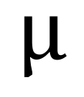. (2 marks)
4. The probability that exactly 9 of the 10 confidence intervals will contain  is greater than the probability that all of the confidence intervals will contain . (3 marks)

**Question 7 (5 marks)**

Sketch on the axes below the set of all complex numbers  which satisfy



 and 

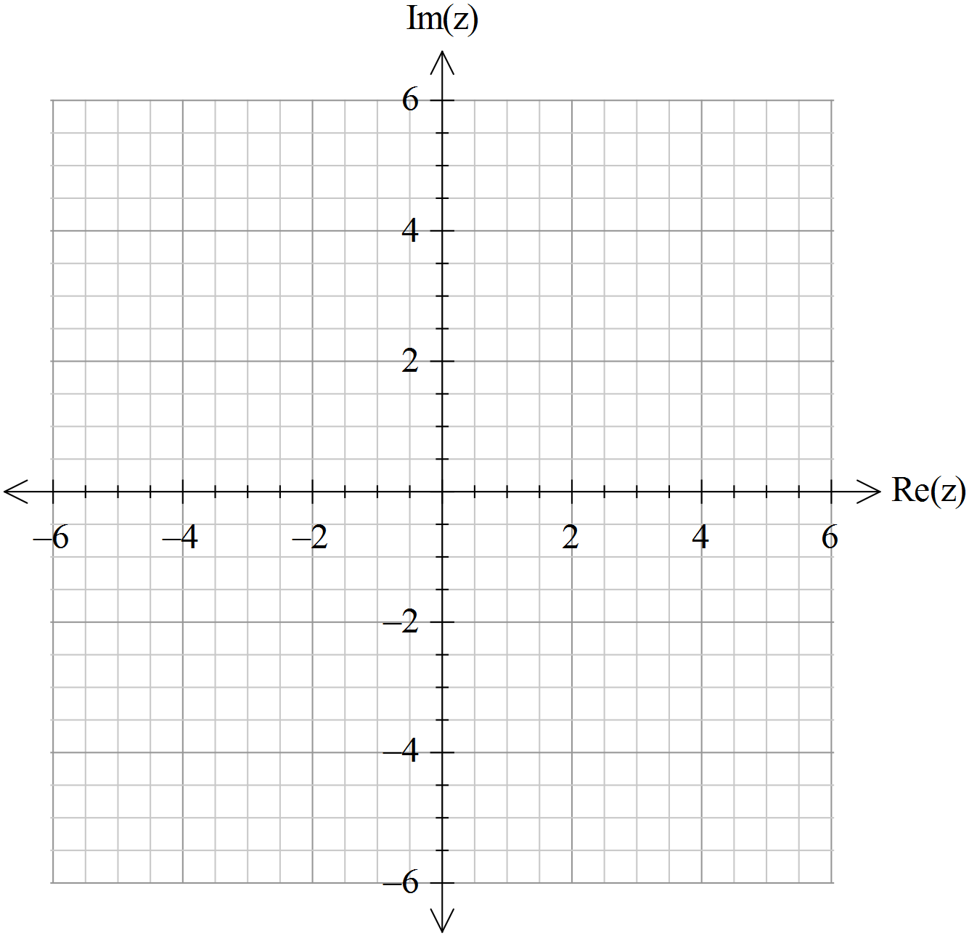

**Additional working space**

Question number: __________________

**Additional working space**

Question number: __________________

**Acknowledgements**

© MAWA, 2018

This examination is Copyright but may be freely used within the school that purchases this licence.

* The items that are contained in this examination are to be used solely in the school for which they are purchased.
* They are not to be shared in any manner with a school which has not purchased their own licence.
* The items and the solutions/marking keys are to be kept confidentially and not copied or made available to anyone who is not a teacher at the school. Teachers may give feedback to students in the form of showing them how the work is marked but students are not to retain a copy of the paper or the marking guide until the agreed release date stipulated in the purchasing agreement/licence.

*Published by The Mathematical Association of WA*

*12 Cobbler Place, MIRRABOOKA 6164.*